C++ Naloge Maj Markez 4.a

Vsebina

1. SWITCH Sklop 1 2

Naloga 1 2

Naloga 2 3

Naloga 3 4

Naloga 4 5

Naloga 5 6

Naloga 6 7

# SWITCH Sklop 1

## Naloga 1

#include <iostream>  
using namespace std;  
  
int main() {  
  
 int x;  
  
 cout << "Marjan zahteva, da vpises poljubno cifro med 1 in 5 :: ";  
 cin >> x;  
  
 switch (x) {  
 case 1:  
 cout << "Marjan sporoca, da si vpisal 1" << endl;  
 break;  
 case 2:  
 cout << "Marjan sporoca, da si vpisal 2" << endl;  
 break;  
 case 3:  
 cout << "Marjan sporoca, da si vpisal 3" << endl;  
 break;  
 case 4:  
 cout << "Marjan sporoca, da si vpisal 4" << endl;  
 break;  
 case 5:  
 cout << "Marjan sporoca, da si vpisal 5" << endl;  
 break;  
 default:  
 cout << "Marjan sporoca, da nisi podal cifre med 1 in 5";  
 }  
  
 return 0;  
}

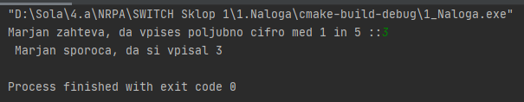

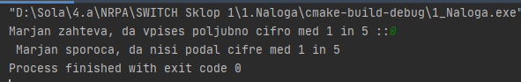

## Naloga 2

#include <iostream>  
using namespace std;  
  
int main() {  
  
 int a,b;  
 char x;  
  
 cout << "Marjan zahteva, da podas p za pravokotnik ali pa k za kvadrat. Podaj tudi stranici a in b ";  
 cin >> x;  
  
 switch (x) {  
 case 'k':  
 cout << "Podali ste kvadrat." << endl;  
 cout << "Podaj se dolzino stranice a ";  
 cin >> a;  
 cout << "Ploscina kvadrata == " << a * a;  
 break;  
 case 'p':  
 cout << "Podali ste pravokotnik." << endl;  
 cout << "Podaj se dolzino stranice a in b ";  
 cin >> a;  
 cin >> b;  
 cout << "Ploscina pravokotnika == " << a * b;  
 break;  
 default:  
 cout << "Nisi vpisal k ali p";  
 }  
  
  
 return 0;  
}

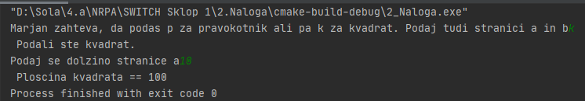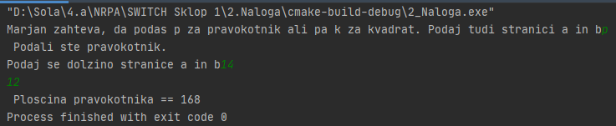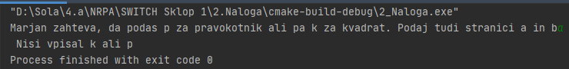

## Naloga 3

#include <iostream>  
using namespace std;  
  
int main() {  
  
 int dan;  
   
 cout << "Napisi poljubno cifro med 1 in 7";  
 cin >> dan;  
  
 switch (dan) {  
 case 1:  
 cout << "Ponedeljek";  
 break;  
 case 2:  
 cout << "Torek";  
 break;  
 case 3:  
 cout << "Sreda";  
 break;  
 case 4:  
 cout << "Cetrtek";  
 break;  
 case 5:  
 cout << "Petek";  
 break;  
 case 6:  
 cout << "Sobota";  
 break;  
 case 7:  
 cout << "Nedelja";  
 break;  
 default:  
 cout << "Nisi vpisal cifre med 1 in 7";  
 break;  
 }  
   
 return 0;  
}

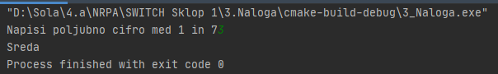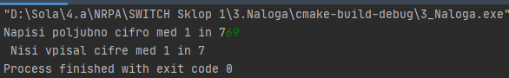

## Naloga 4

#include <iostream>  
using namespace std;  
  
int main() {  
  
 int a, b;  
 char ope;  
  
 cout << "Marjan je naredil kalulator.. Vpisi cifro in operator" << endl;  
  
 cout << "Vpisi operator (+, -, *, /): ";  
 cin >> ope;  
  
 switch (ope) {  
 case '+':  
 cout << "Izbral si SESTEVANJE." << endl;  
 cout << "Vpisi prvo cifro: ";  
 cin >> a;  
 cout << "Vpisi drugo cifro: ";  
 cin >> b;  
 cout << "Rezultat == " << a + b;  
 break;  
 case '-':  
 cout << "Izbral si ODSTEVANJE." << endl;  
 cout << "Vpisi prvo cifro: ";  
 cin >> a;  
 cout << "Vpisi drugo cifro: ";  
 cin >> b;  
 cout << "Rezultat == " << a - b;  
 break;  
 case '*':  
 cout << "Izbral si MNOZENJE." << endl;  
 cout << "Vpisi prvo cifro: ";  
 cin >> a;  
 cout << "Vpisi drugo cifro: ";  
 cin >> b;  
 cout << "Rezultat == " << a * b;  
 break;  
 case '/':  
 cout << "Izbral si DELJENJE." << endl;  
 cout << "Vpisi prvo cifro: ";  
 cin >> a;  
 cout << "Vpisi drugo cifro: ";  
 cin >> b;  
 cout << "Rezultat == " << a / b;  
 break;  
 default:  
 cout << "Nisi vpisal pravega operatorja. (+, -, *, /)";  
 break;  
 }  
  
 return 0;  
}

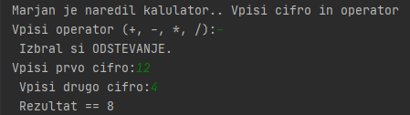

## Naloga 5

#include <iostream>  
using namespace std;  
  
int main() {  
  
 int st;  
  
 cout << "Napisi poljubno cifro med 1 in 9";  
 cin >> st;  
  
 switch (st) {  
 case 1:  
 cout << "ENA";  
 break;  
 case 2:  
 cout << "DVA";  
 break;  
 case 3:  
 cout << "TRI";  
 break;  
 case 4:  
 cout << "STIRI";  
 break;  
 case 5:  
 cout << "PET";  
 break;  
 case 6:  
 cout << "SEST";  
 break;  
 case 7:  
 cout << "SEDEM";  
 break;  
 case 8:  
 cout << "OSEM";  
 break;  
 case 9:  
 cout << "DEVET";  
 break;  
 default:  
 cout << "Nisi vpisal cifre med 1 in 9";  
 break;  
 }  
  
 return 0;  
}

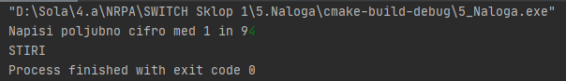

## Naloga 6

#include <iostream>  
using namespace std;  
int main() {  
  
 char x;  
  
 cout << "Vpisi random stvar (samo en znak) :: ";  
 cin >> x;  
  
 switch (x) {  
 case 'A'...'Z':  
 case 'a'...'z':  
 cout << "To je crka.";  
 break;  
 case '0'...'9':  
 cout << "To je stevilka.";  
 break;  
 default:  
 cout << "To je posebni znak.";  
 break;  
 }  
  
 return 0;  
}

